POZIV ZA MEDIJE

Poštovane/poštovani,

ZAVOD ZA ENDOKRINOLOGIJU KBC ZAGREB
MEDICINSKI FAKULTET SVEUČILIŠTA U ZAGREBU
pod pokroviteljstvom
RAZREDA ZA MEDICINSKE ZNANOSTI
HRVATSKE AKADEMIJE ZNANOSTI I UMJETNOSTI
organiziraju
Simpozij
Klinička endokrinologija
15.-16.2013., Zagreb

Preporodna dvorana palače Narodnog doma, Opatička 18

Simpozij 'Klinička endokrinologija' je tradicionalno okupljanje endokrinologa iz regije, satanak na kojem se razmjenjuju znanstvena iskustva i ideje te dogovaraju budući znanstveni projekti. I ove godine kao predavači na simpoziju, uz domaće, sudjeluju i vodeći europski i svjetski stručnjaci iz pojedinih područja endokrinologije. Predavanja na simpoziju biti će klinički orijentirana, a na radionicama će sudionici aktivno sudjelovati izlažući neki medicinski zanimljiv, edukativan ili pak nerazjašnjen slučaj iz vlastite kliničke prakse.
Za sudjelovanje na simpoziju ove godine se prijavilo više od 120 sudionika iz deset različitih zemalja.

Predsjednik simpozija:
Doc. dr. sc. Darko Kaštelan, Medicinski fakultet Sveučilišta u Zagrebu, KBC Zagreb

U prilogu Vam dostavljamo Program simpozija.

Za više informacija: Doc.dr. sc. Darko Kaštelan, dkastelan@inet.hr, fax: 01/2376036
Srdačno Vas pozdravljamo, zahvaljujemo na suradnji i očekujemo Vaš dolazak.

Gordana Poletto Ružić,
Odnosi s javnošću HAZU

POSTGRADUATE COURSE
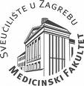 CLINICAL ENDOCRINOLOGY 
Zagreb, March 15-16, 2013

Course venue

Croatian Academy of Sciences and Arts
Opaticka 18

We are delighted to present the program of the 4th Postgraduate Course in Clinical Endocrinology which will take place in Zagreb in March 2013. Our goal is to provide the participants with an opportunity to meet distinguished international speakers as well as to network with colleagues from the region.

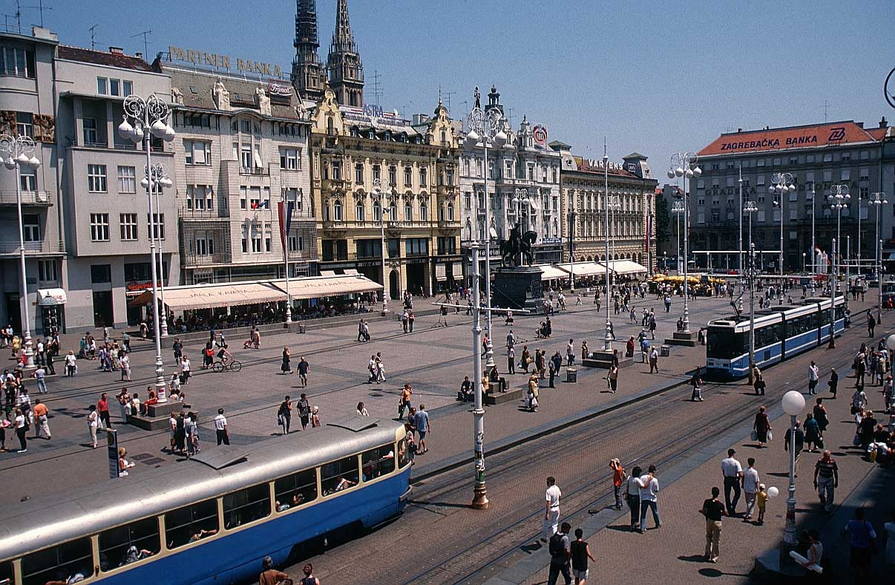

We look forward to seeing you in Zagreb in March 2013.

Darko Kastelan, Course President
Zagreb University School of Medicine, University Hospital Center Zagreb

CLINICAL ENDOCRINOLOGY
Zagreb, March 15-16, 2013

PROGRAM

Friday, March 15

09,45 -10,00 Course opening

10,00-10,40 Targeted medical therapy in Cushing's: challenging cases V. Popovic, Serbia

10,40-11,20 Management of adrenal incidentalomas: facts and figures M. Terzolo, Italy
11,20-11,50 Coffee break

11,50-13,45 WORKSHOP: Adrenal Chair: Terzolo, Kastelan

1. Kraljević (Croatia): Predictive value of CT imaging in the diagnosis of pheochromocytoma
2. Tripolski (Croatia): Is it Cushing’s syndrome?
3. Kraljević (Croatia): Bilateral adrenal masses and SCS
4. Pekez (Croatia): Epidemiologic characteristics of patients with ACC and dilemmas in the treatment of ACC
5. Ahmeti (Macedonia): Ectopic ACTH syndrome and refractory hypokalemia
6. Mlekuš (Slovenia): Ectopic ACTH syndrome
7. Canecki (Croatia): Etomidate in the treatment of CS
8. Škorić Polovina (Croatia): Primary hiperaldosteronism - what to do after an unsuccessful AVS?
9. Miljić (Serbia): Polycythemia, paragangliomas and somatostatinomas

13,45-14,30 Lunch

14,30-15,10 Genes and giants - familial pituitary adenomas M. Korbonits, UK

15,10–17,30 WORKSHOP: Pituitary Chair: Popovic, Korbonits

1. Doknić (Serbia): Congenital hypopituitarism
2. Kraljevic (Croatia): Pituitary carcinoma
3. Pekić (Serbia): Intrasellar plasmocytoma
4. Dušek (Croatia): Cerebral lymphoma and DI
5. Bajuk Studen (Slovenia): Neurosarcoidosis in the hypothalamic-pituitary region: a treatment challenge
6. Bilić Čurčić (Croatia): Unexplained case of recurrent hyponatremia

Saturday, March 16

09,00–09,40 PCOS and cardiometabolic risk M. Pfeifer, Slovenia

09,40–10,20 The role of autoimmunity in pituitary disorders F. Kelestimur, Turkey

10,20-10,40 Coffee break

10,40-12,15 WORKSHOP: PCOS, Reproductive endocrinology, Infertility
Chair: Pfeifer, Macut

1. Duraković (Croatia): Chemotherapy and premature ovarian failure
2. Peroš (Croatia): Induction of spermatogenesis with hCG/hMG therapy in a patient with Kallmann’s syndrome
3. Alebić (Croatia): Bromocriptine treatment in pregnancy and recurrent pregnancy loss
4. Solak (Croatia): Hyperandrogenism: is it from the adrenal or from the ovary?
5. Medić (Serbia): Von Hippel Lindau disease and pregnancy

12,15 -13,00 Lunch

13,00-13,40 Targeting HbA1c level in different groups of patients L. Olansky, USA

13,40-14,40 WORKSHOP: Diabetes Chair: Olansky, Renar

1. Petrovski (Macedonia): Ambulatory glucose profile (cgm) as decision making tool in patients with diabetes: insulin therapy or other agents?
2. Bakula (Croatia): Resistant insulin allergy in a patient treated for breast carcinoma
3. Čavlović (Croatia): Diabetes mellitus and MGUS - interference with HbA1c laboratory test

14,40-14,50 Coffee break

14,50 – 15,30 Difficult diabetes cases M. Skugor, USA

15,30-17,30 WORKSHOP: Bone, Thyroid Chair: Korsic, Dusek

1. Krokter Kogoj (Slovenia): Young man with fractures and hypophyosphatemia
2. Pandzic Jaksic (Croatia): Hungry bone syndrome after parathyroidectomy in a patient with renal osteodystrophy
3. Baretić (Croatia): Camuratti Engelman syndrome
4. Magaš (Croatia): Severe osteoporosis in an elderly man
5. Marić (Croatia): Multiple bone fractures and osteomalatia
6. Žmire (Croatia): Pseudohypoparathyreoidism
7. Bakula (Croatia): Lithium in the treatment of hyperthyroidism
8. Jovanovska (Macedonia): Endocrine manifestations of thalassemia major

