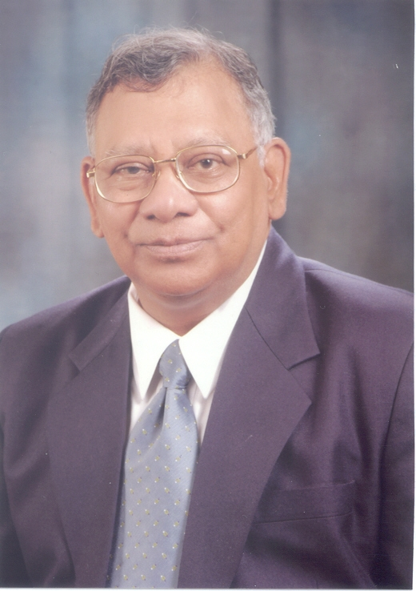
CV: Dr. Kashmiri L. Mittal

Dr. Kashmiri Lal Mittal was associated with the IBM Corporation from 1972 through 1993. Currently, he is teaching and consulting worldwide in the broad areas of adhesion as well as surface cleaning. He has initiated, organized and chaired a large number of international symposia, and is the editor of 112 published books as well as others which are in the process of publication dealing, inter alia, with adhesion measurement, adhesion of polymeric coatings, polymer surfaces, adhesive joints, adhesion promoters, thin films, polyimides, surface modification, surface cleaning, and surfactants. He has received many awards and honors . He is a Robert L. Patrick Fellow of the Adhesion Society and is listed in many biographical reference works. He was the Editor-in-Chief of the Journal of Adhesion Science and Technology until April 2012, and is/has been a member of the editorial boards of a number of scientific and technical journals. Dr. Mittal was recognized for his contributions and accomplishments by the worldwide adhesion community by organizing in his honor on his 50th birthday the 1st International Congress on Adhesion Science & Technology in Amsterdam in 1995. In 2002 he was honored by the global surfactant community by inaugurating the Kash Mittal Award in the surfactant field in his honor for his large efforts and significant contribution to the field of colloid and interface chemistry. In 2003 he was honored by the Maria Curie-Sklodowska University, Lublin, Poland by awarding him the title of doctor honoris causa. In 2006 he was recognized by dedicating Volumes 123-126 of the Advances in Colloid and Interface Science in his honor on his 60th birthday. In 2010 he was recognized for publication of 100 edited books by two symposia held in his honor: Symposium on Recent Advances in Adhesion Science and Technology held at the American Chemical Society meeting in Boston, and Symposium on Surfactant Science and Technology: Retrospects and Prospects held in Melbourne, Australia.
He is the Founding Editor of the journal Reviews of Adhesion and Adhesives which made its debut in February 2013.

